**Ants Assembly Instructions**

Content

Bot in default state (incl. Pull-Up Resistor) 3

1. Preparation of the Ping-Sensor + Assembly 4

2. Bracket for Line-Follower 5

3. Preparation of the Line Follower 6

4. Assembly of the Line Follower 7

5. Wiring of the Line Follower 9

6. Wiring of the Ultrasonic Distance Sensor 11

7. Connection of the WiFi-Modul (ESP-8266) 12

# Bot in default state (incl. Pull-Up Resistor)

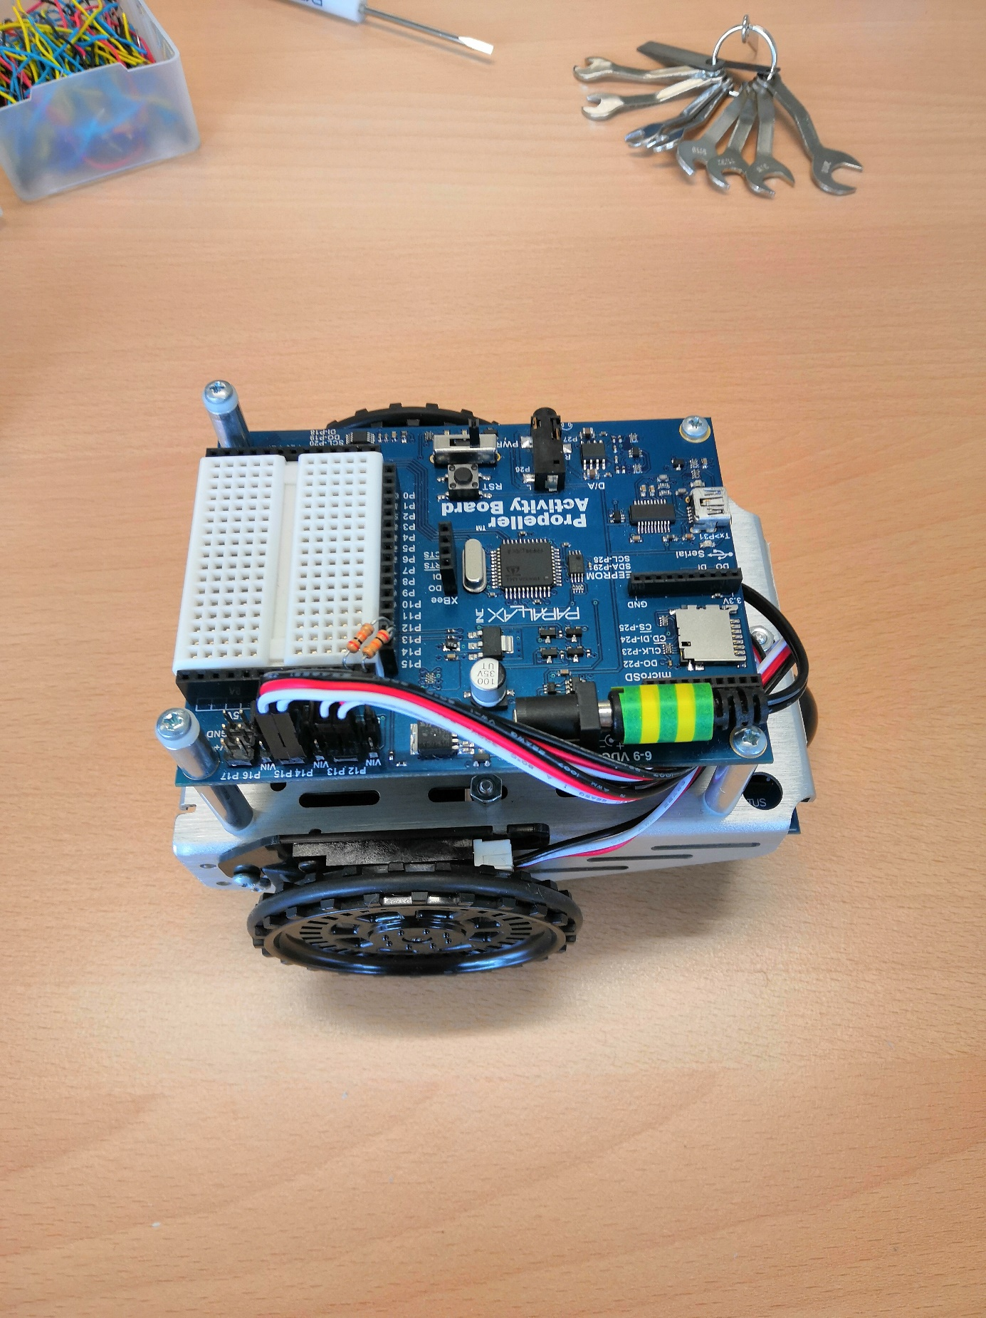

# Preparation of the Ping-Sensor + Assembly

Required Parts

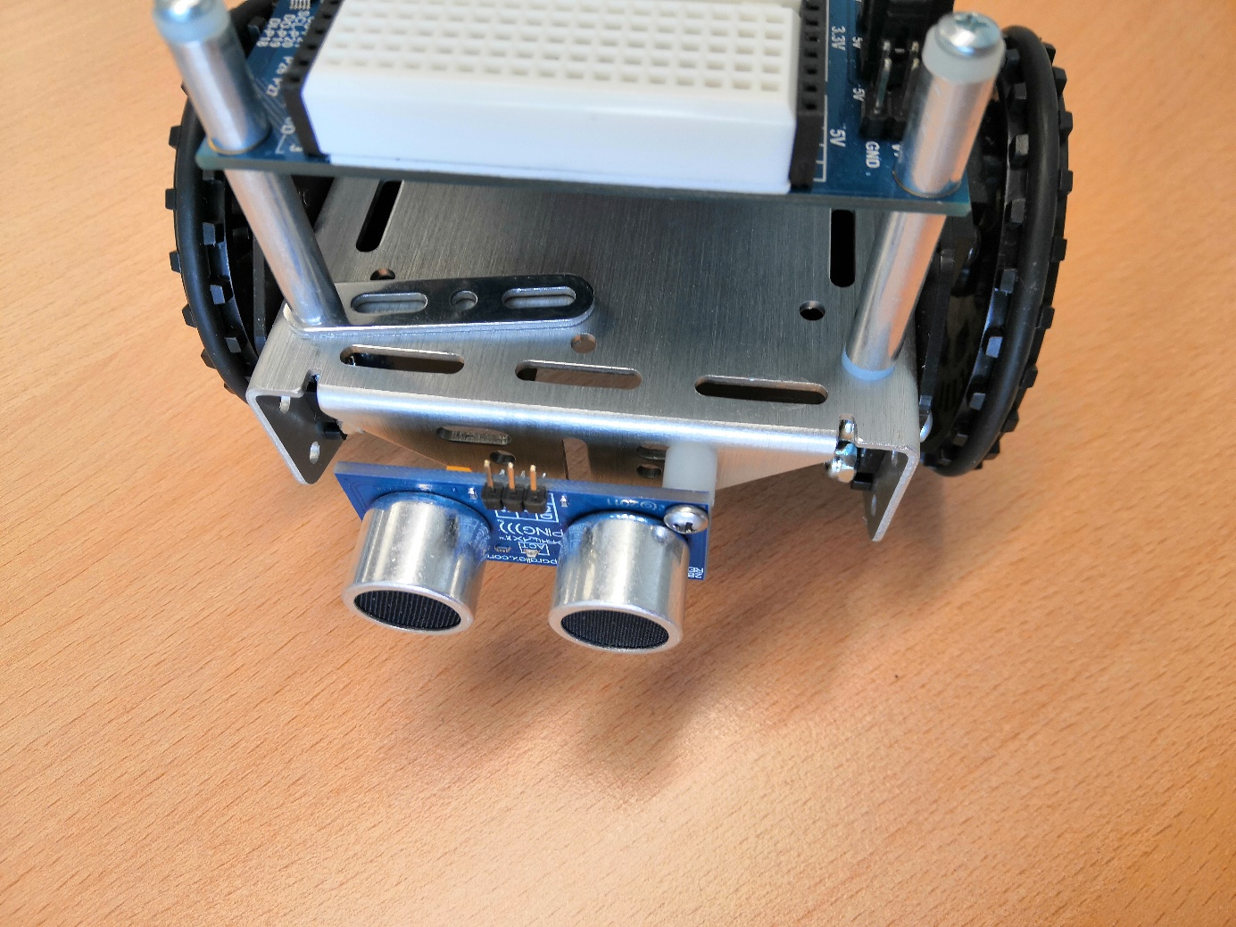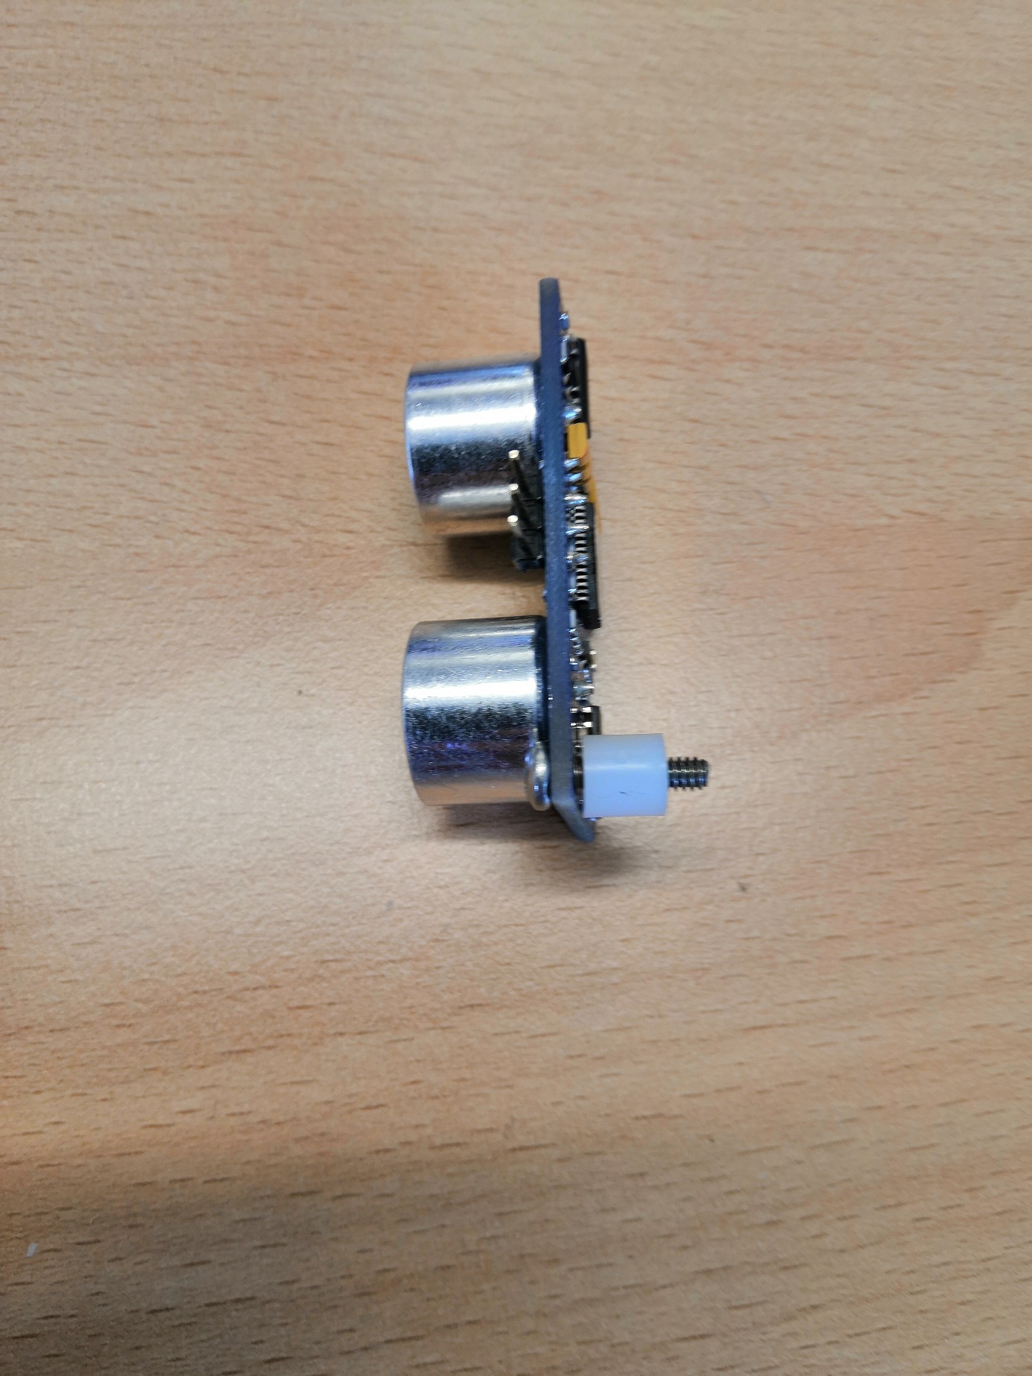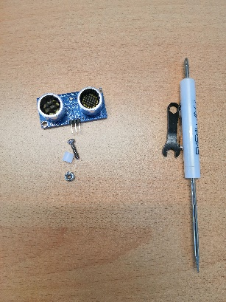

Assembly

# Bracket for Line-Follower

Don’t fully tighten screws yet!

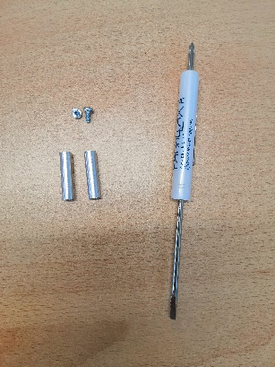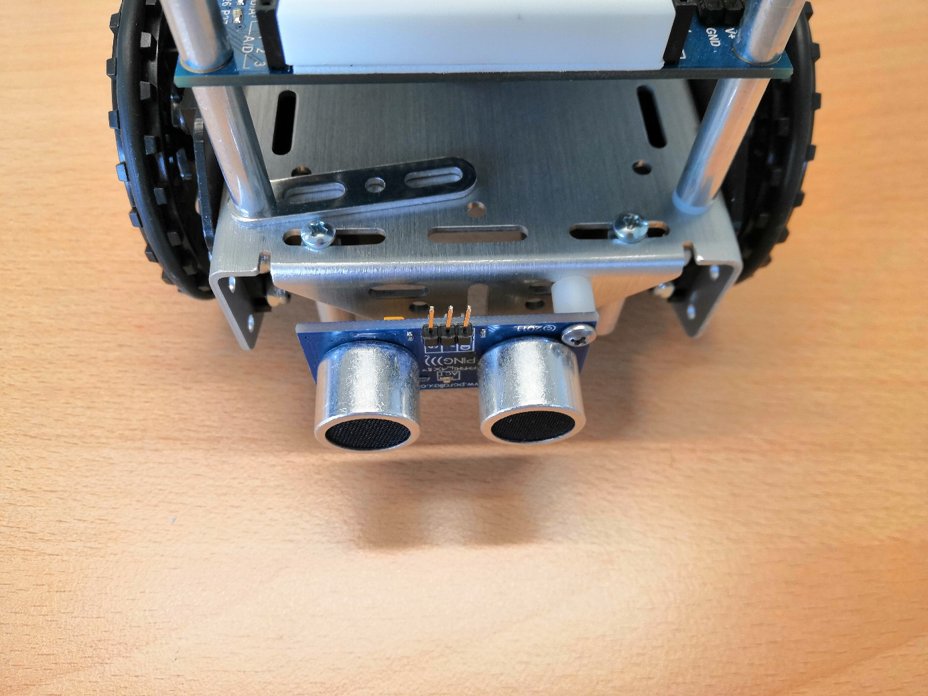

Required Parts

# Preparation of the Line Follower

STL-file for 3D-printing the schield can be found in the *antshield*-directory

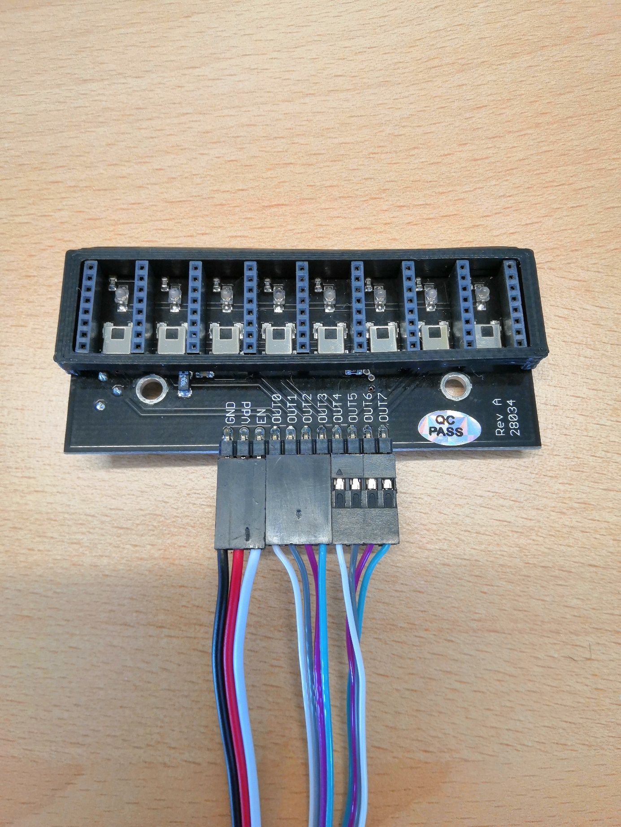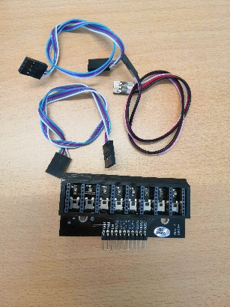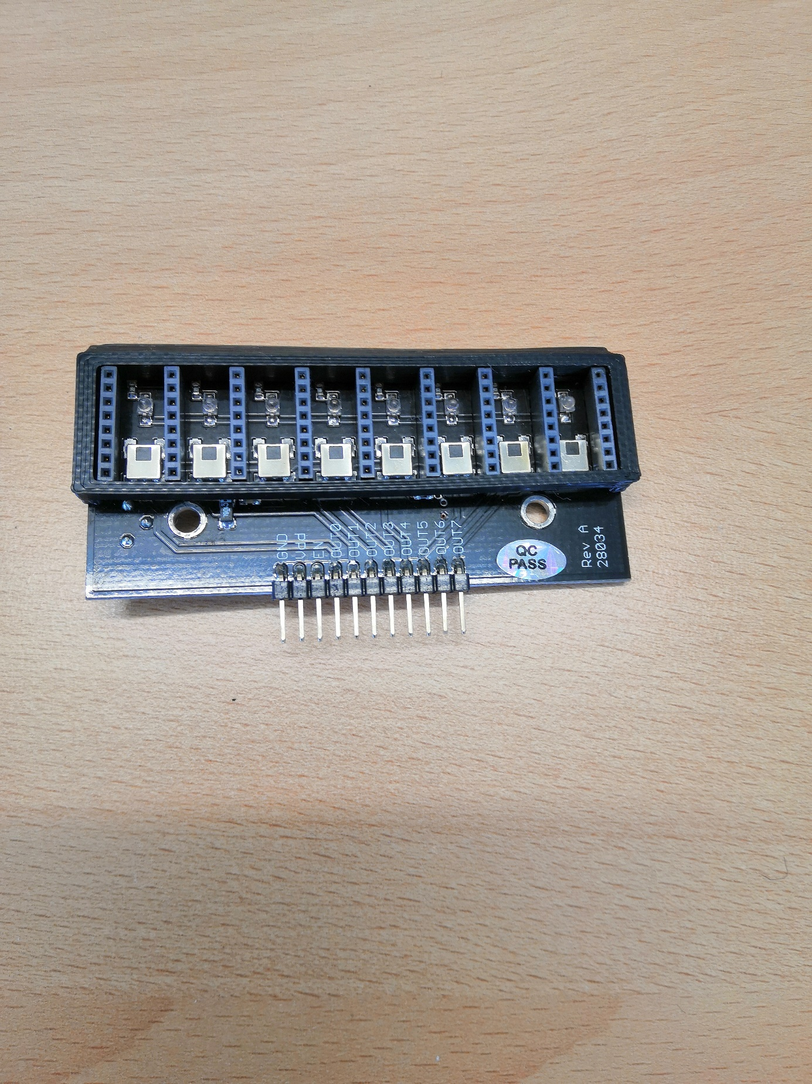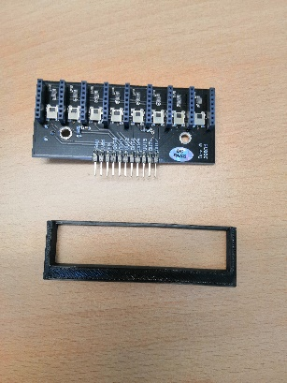

Required Parts

Required Parts

# Assembly of the Line Follower

Required Parts

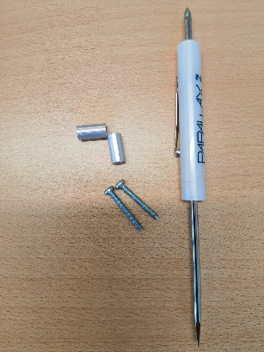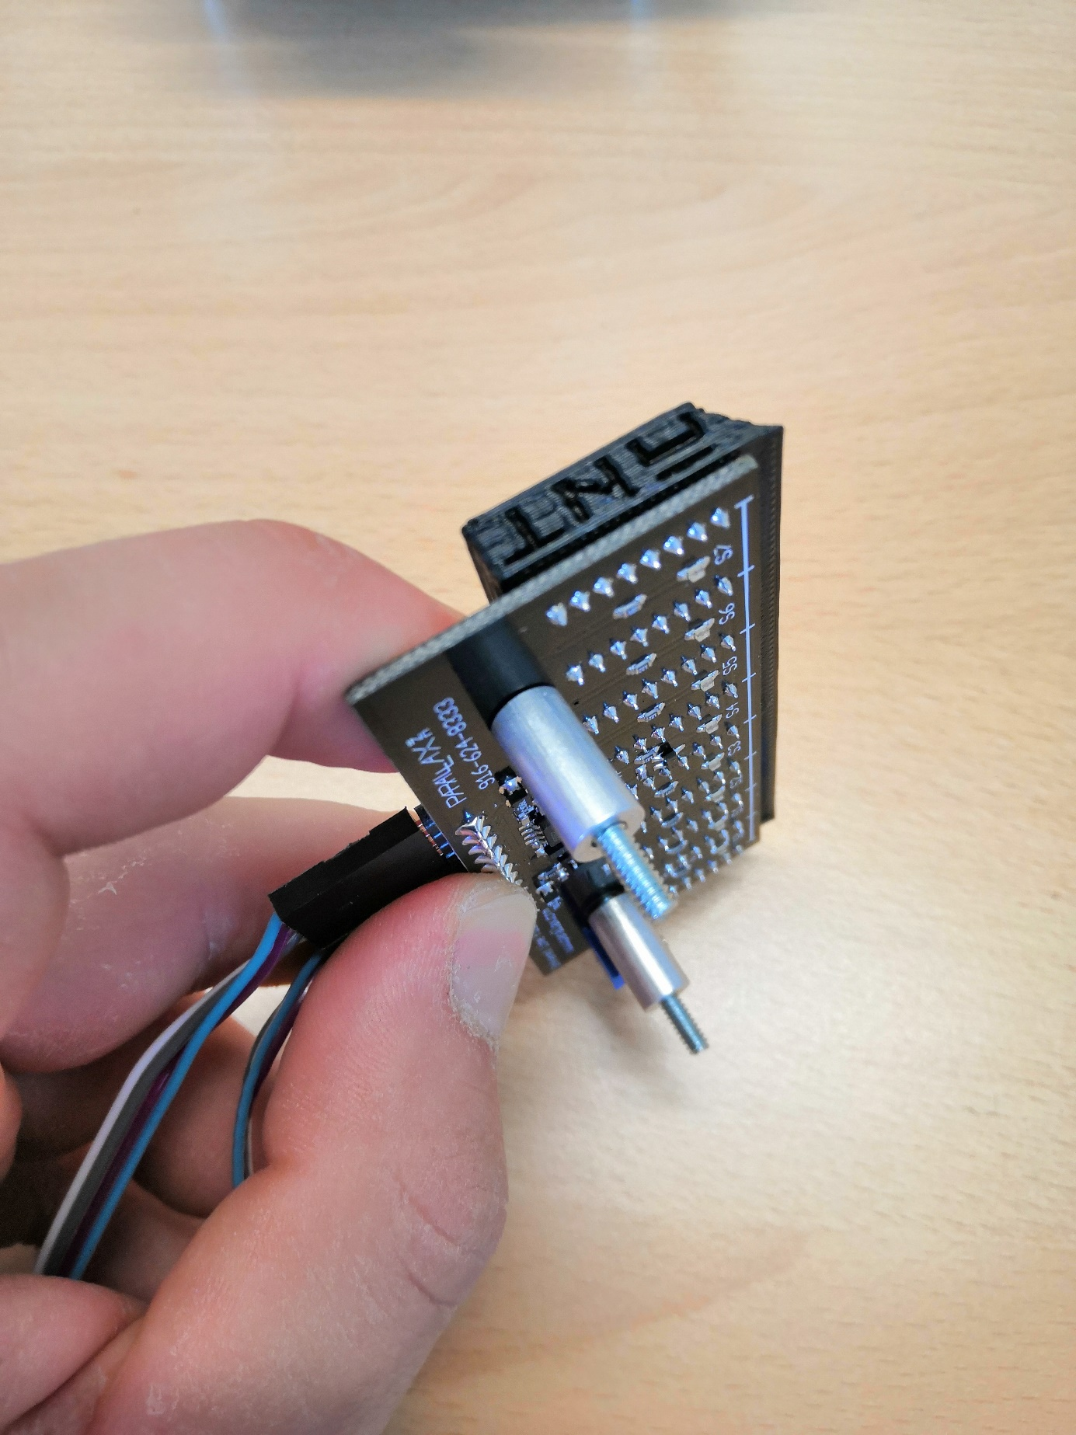

After the assembly the highlighted screws from step 2 can be fully tightened.

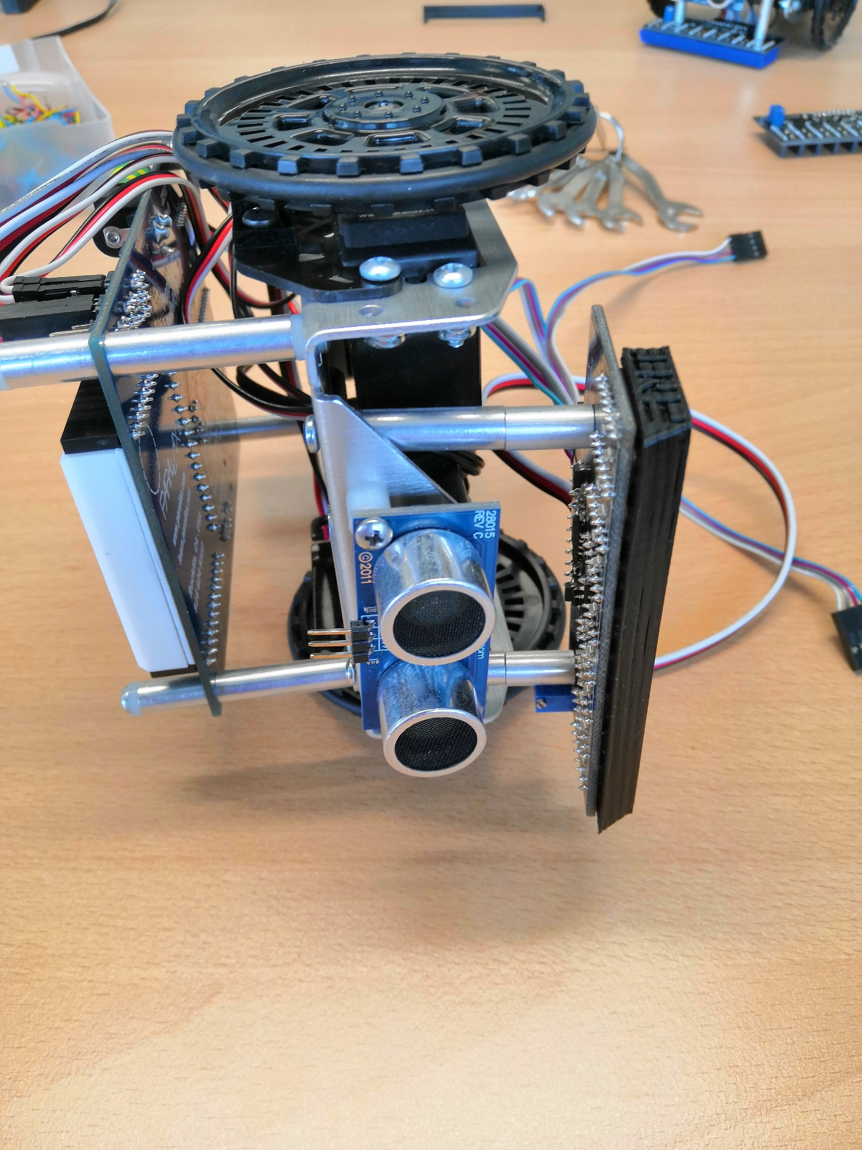

Assembly

# Wiring of the Line Follower

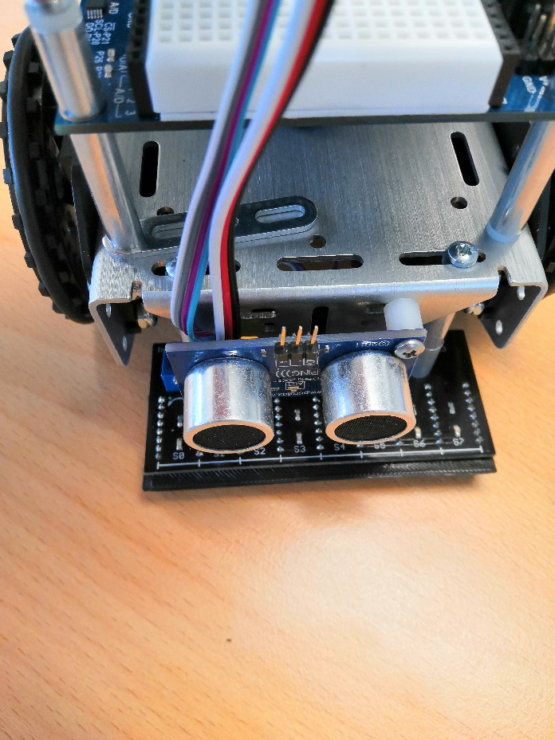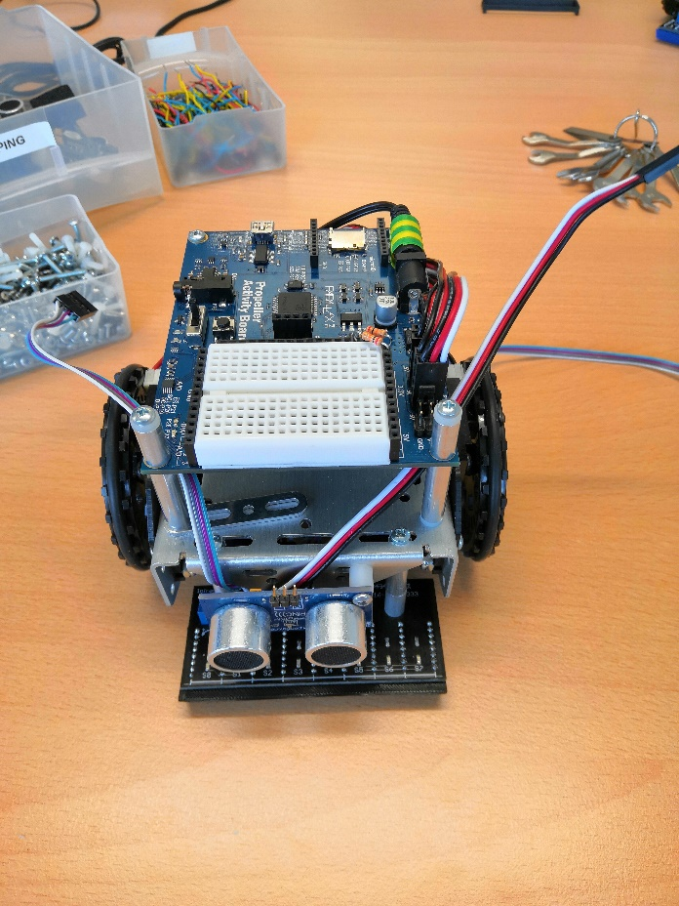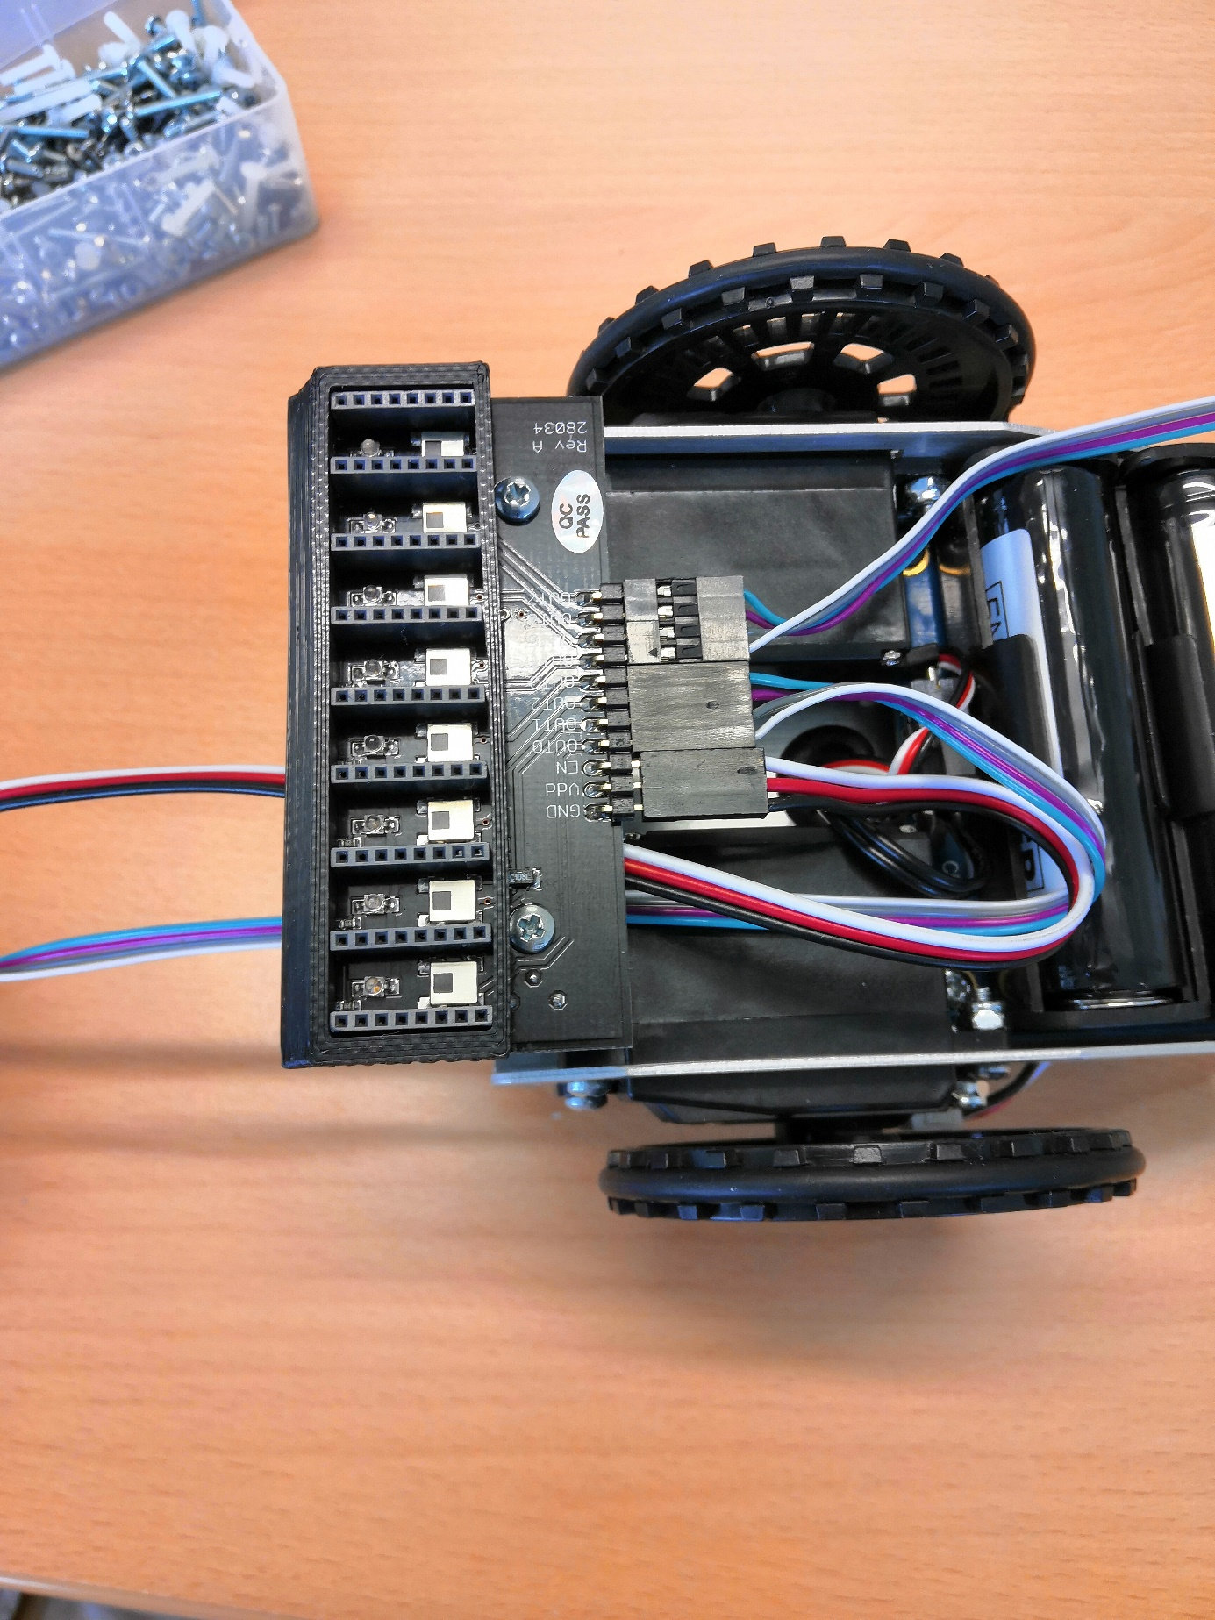

Wiring

1. Connect powercable with 3pin wire to 5V delivery (Jumper has to be set to 5V)
2. 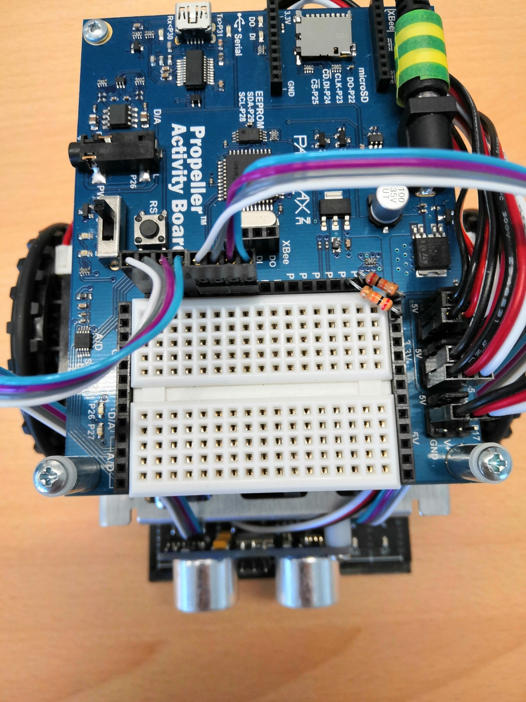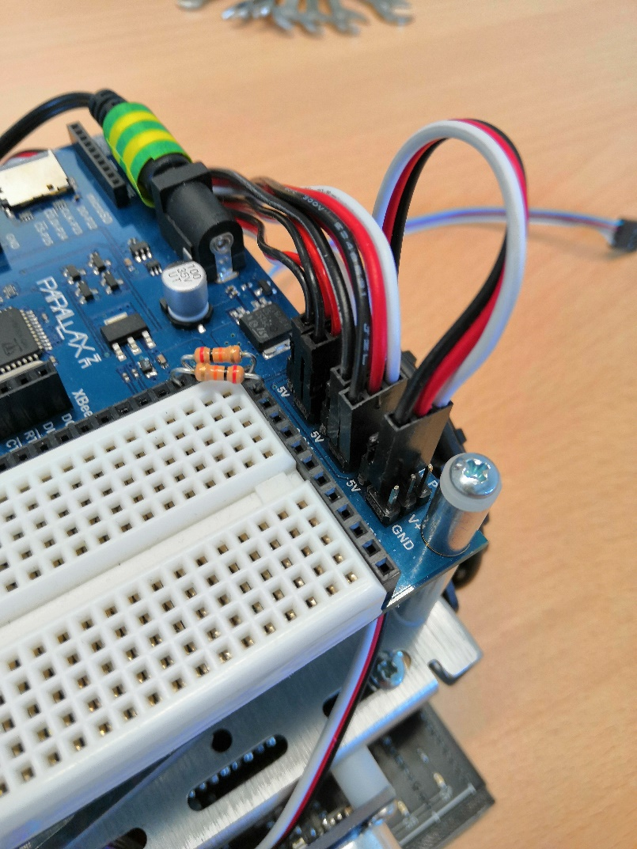Connect datacable to ports P0-P7 (S0 of the Line Followers into P0)

Wiring

# Wiring of the Ultrasonic Distance Sensor

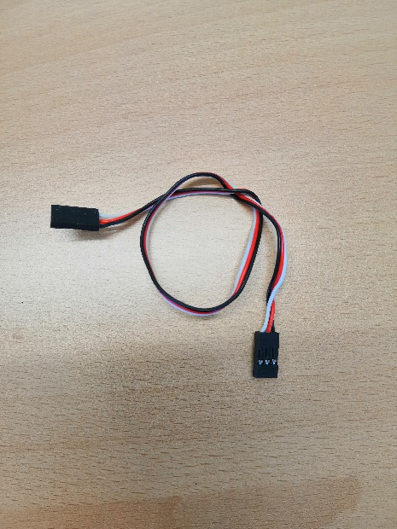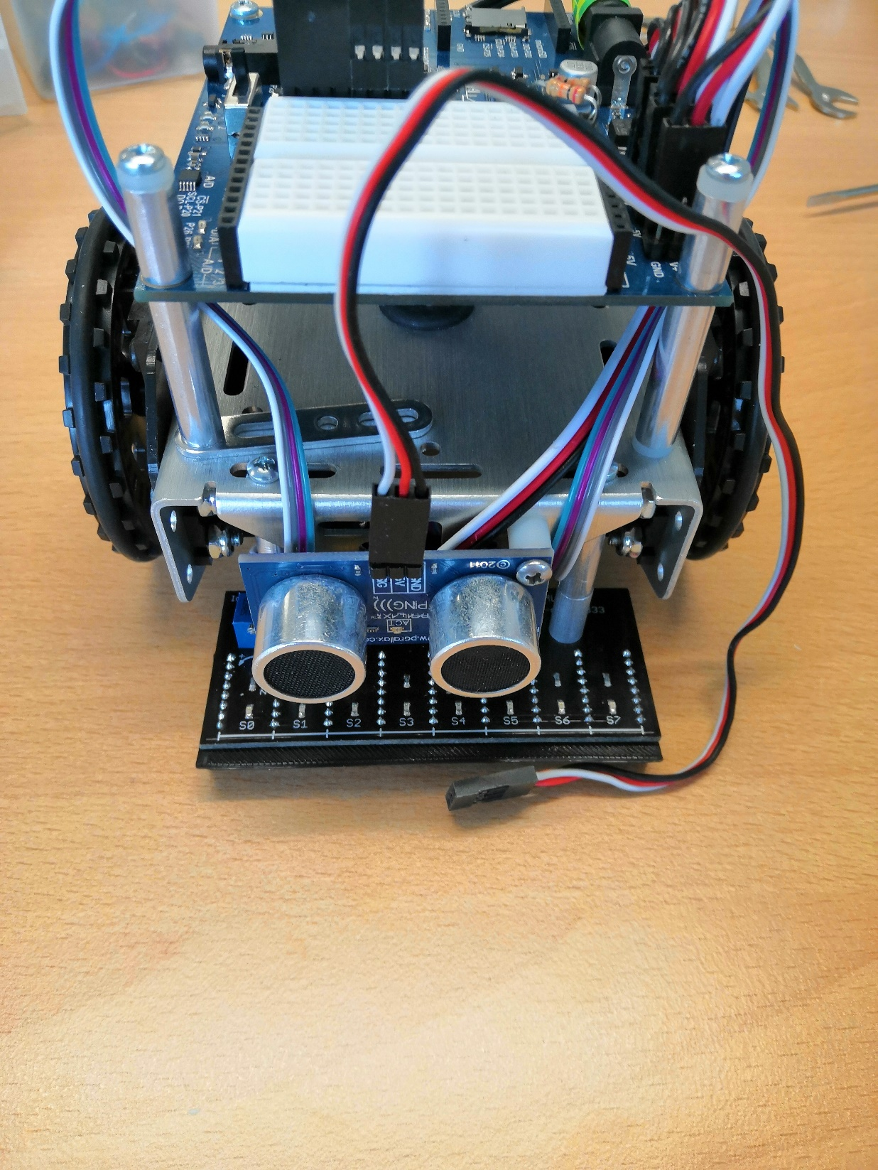

Required Parts

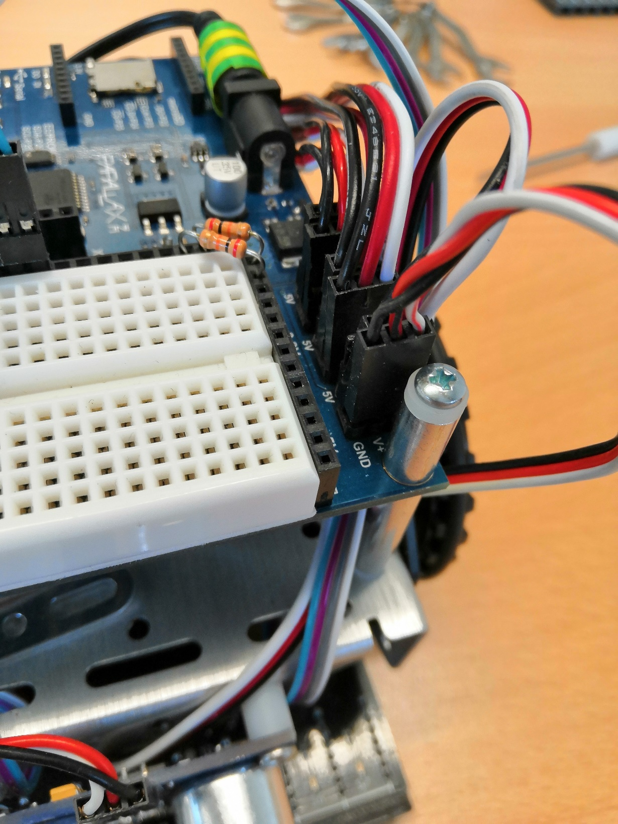

# Connection of the WiFi-Modul (ESP-8266)

1. WiFi-Module gets plugged on
2. Connect DI to P8 and DO to P9
3. Change the settings oft he WiFi-Moduls to AP-Mode with the name & password of the WiFi-Network in the web-interface

